Week 5 Assignment Outputs (Archit Sahay - Amity School of Engineering and Technology)
Q.) Why PySpark over MapReduce(Hadoop)?
Ans.) MapReduce limitations is that it relies on disk-based processing. After every map and reduce stage, intermediate data is written to disk, which makes processing slower, especially for iterative tasks and real-time analytics.
Spark follows an in-memory processing, where data can be stored in RAM instead of repeatedly reading and writing to disk. This makes Spark significantly faster than MapReduce, especially for large-scale data processing, machine learning, and repeated computations.

Q.) What is the concept of immutability in PySpark?
Ans.) Pyspark Dataframes are immutable and they don’t change after operations are performed instead each operation are done a completely new copy of the original dataframe we have to assign it to a new df whenever we make changes so that the original df remains unchanged throughout the procedure of this cleaning

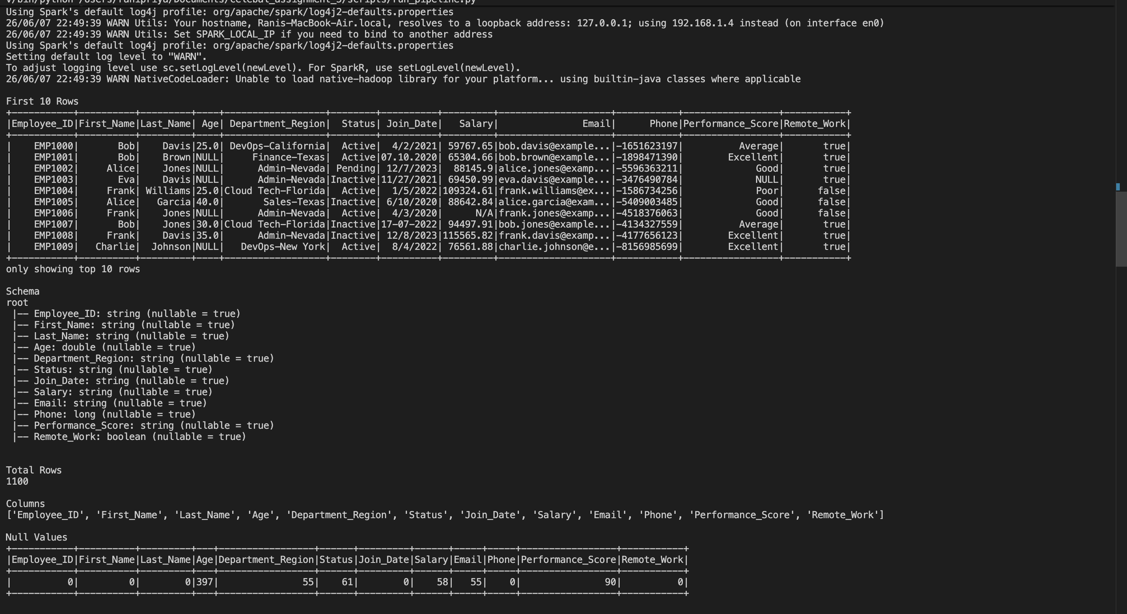
Outputs after Inspection, Cleaning and modifying the raw dataset and completing filtering and aggregation operations

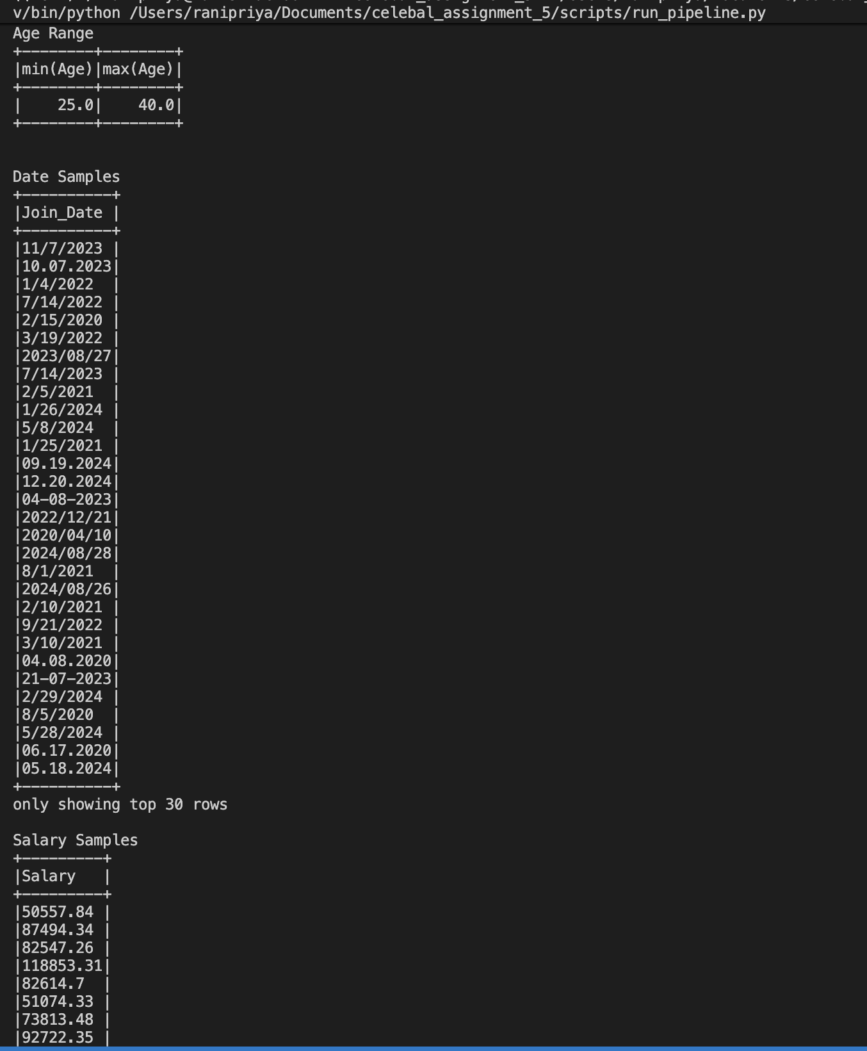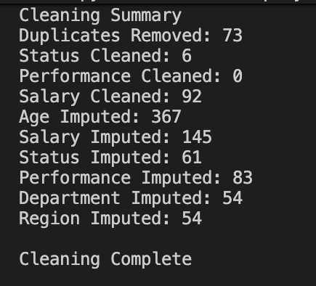
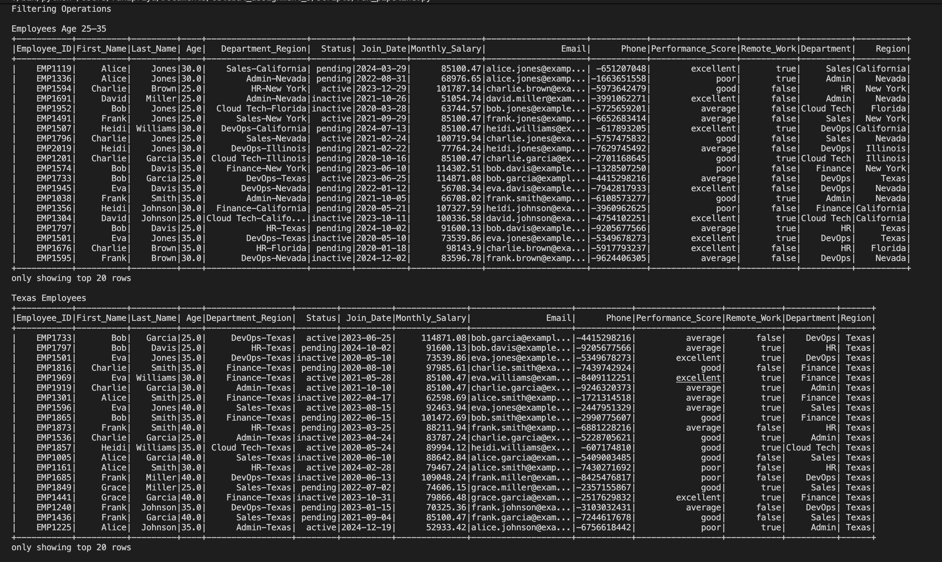

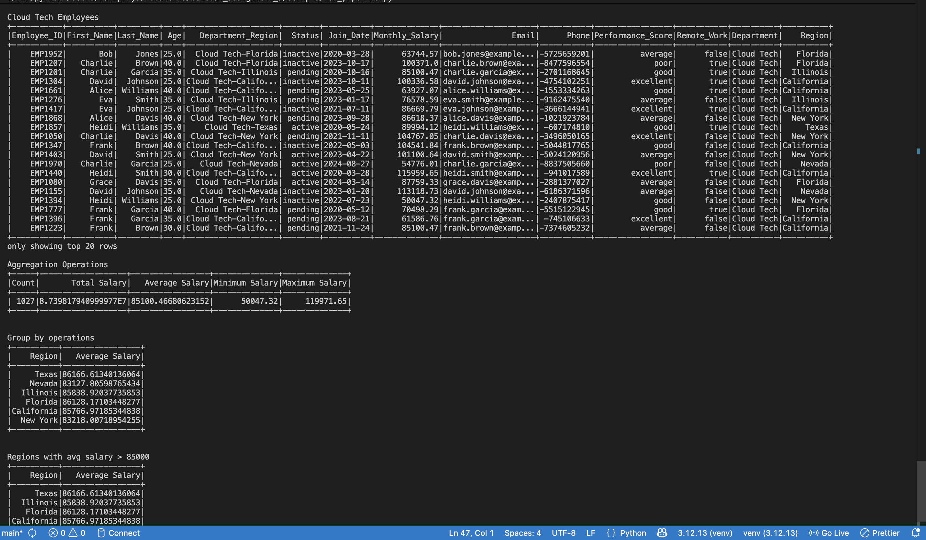

Brief Insights on Data preprocessing and transformations:
The data processing and transformation step mainly focused on cleaning and standardizing the dataset to make it usable for analysis. Duplicate records were removed to avoid repeated data, while null, empty, and invalid values were handled properly for consistency.
Different formats in the data were standardized, such as cleaning text values, fixing date formats, and converting columns to the correct datatype where required. Missing numerical values were filled using mean and categorical values using mode to reduce data loss and keep the dataset usable. Some columns were also split into separate meaningful features to improve readability and analysis. Overall, the transformations helped convert raw, inconsistent data into a cleaner and more structured format.

